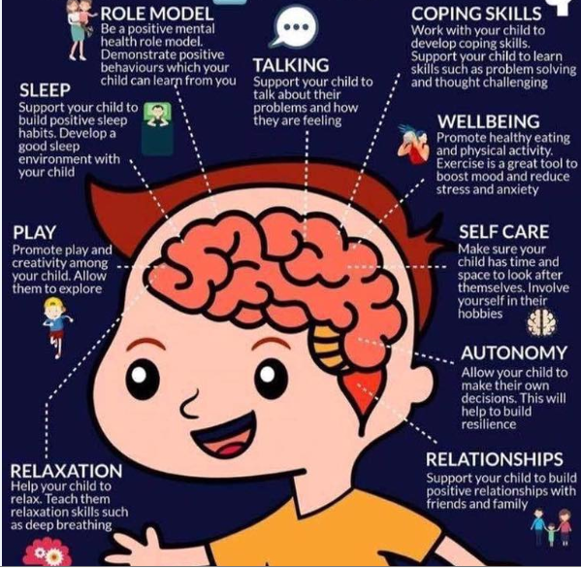**10 ways to help your child look after their Mental Health**